

**Software Design & Architecture**

**SECJ3323 Section 04**

**Lab Exercise 1**

**<Car Rental System>**

**Team Member:**

**1.Khaled Osama Tahoon A22EC4033**

**2.Omar Abdelmonem Hanafy A22EC4012**

**3.Daffa Tangguh Ananda Kurniawan A21EC4042**

**4.Feng Yiyang A20EC4020**

**5.Ruslan Zagidullin X24EC0005**

1. **Use Case Diagram**

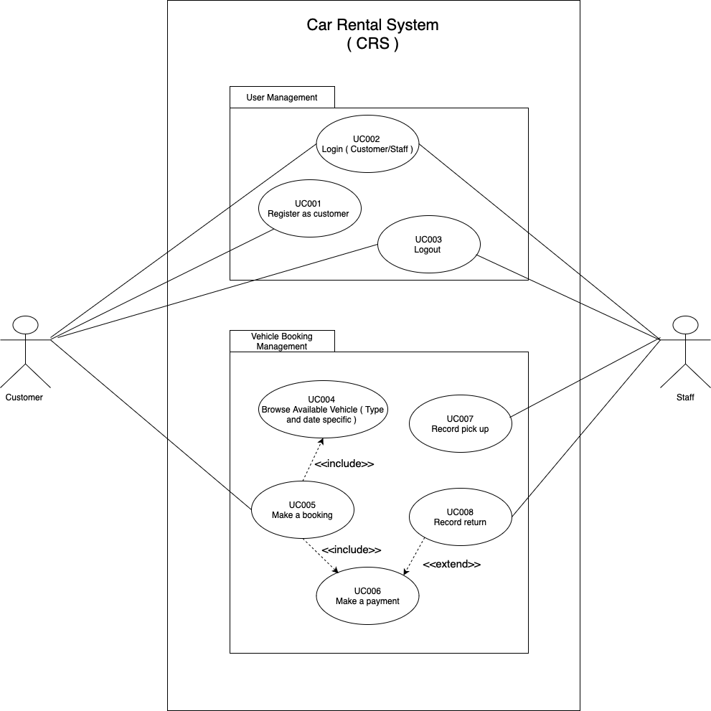

1. **Happy Scenario**

**UC Make a Booking**

**Primary Actor: Customer**

**Secondary Actor: System**

**Preconditions:**

- The customer is registered and logged into the system.

- The system has vehicles available for booking in its database.

**Normal Flow (Happy Day Scenario):**

**1. Customer initiates booking:**

- The customer selects the option to "Browse Vehicles" from the booking interface.

**2.Customer searches for available vehicles:**

- The system prompts the customer to enter search criteria, including vehicle type (e.g., Sedan, SUV) and dates for rental (pick-up and return dates).

- The customer inputs the type of vehicle and the desired rental period.

**3. System checks vehicle availability:**

- The system checks its database for available vehicles that match the customer's criteria (type and date).

- If one or more vehicles are available, the system presents a list of suitable vehicles, showing details such as model, price, and features.

**4. Customer selects a vehicle:**

- The customer selects a vehicle from the list of available options.

- The system then displays the selected vehicle’s details (e.g., vehicle model, rental price, rental period) for confirmation.

**5. System confirms booking details:**

- The system presents a summary of the booking, including:

* Vehicle type and model.

* Pick-up and return dates.

* Total rental price.

- The customer reviews the summary.

**6. Customer confirms the booking:**

- The customer clicks "Confirm Booking" to proceed.

**7. Payment process is initiated:**

- The system redirects the customer to the payment gateway.

- The customer selects a payment method (e.g., credit card, digital wallet) and enters payment details.

**8. System processes the payment:**

- The system validates the payment through the payment gateway and deducts the rental amount from the customer’s account.

- Upon successful payment, the system updates the booking in the database:

* Marks the selected vehicle as "booked" for the specified period.

* Updates the vehicle's availability in the system's schedule.

**9. System sends confirmation:**

- The system generates a booking confirmation that includes:

* The booking reference number.

* Vehicle details.

* Pick-up and return dates.

* Location for pick-up.

- The system sends this confirmation to the customer via email and in-app notification.

**10. Customer receives booking confirmation:**

- The customer sees the confirmation details on the screen and receives the email confirmation.

Postconditions:

- The vehicle is booked and marked unavailable for the specified rental period.

- The customer has a confirmed booking and can view it in their account.

1. **Sequence Diagram**

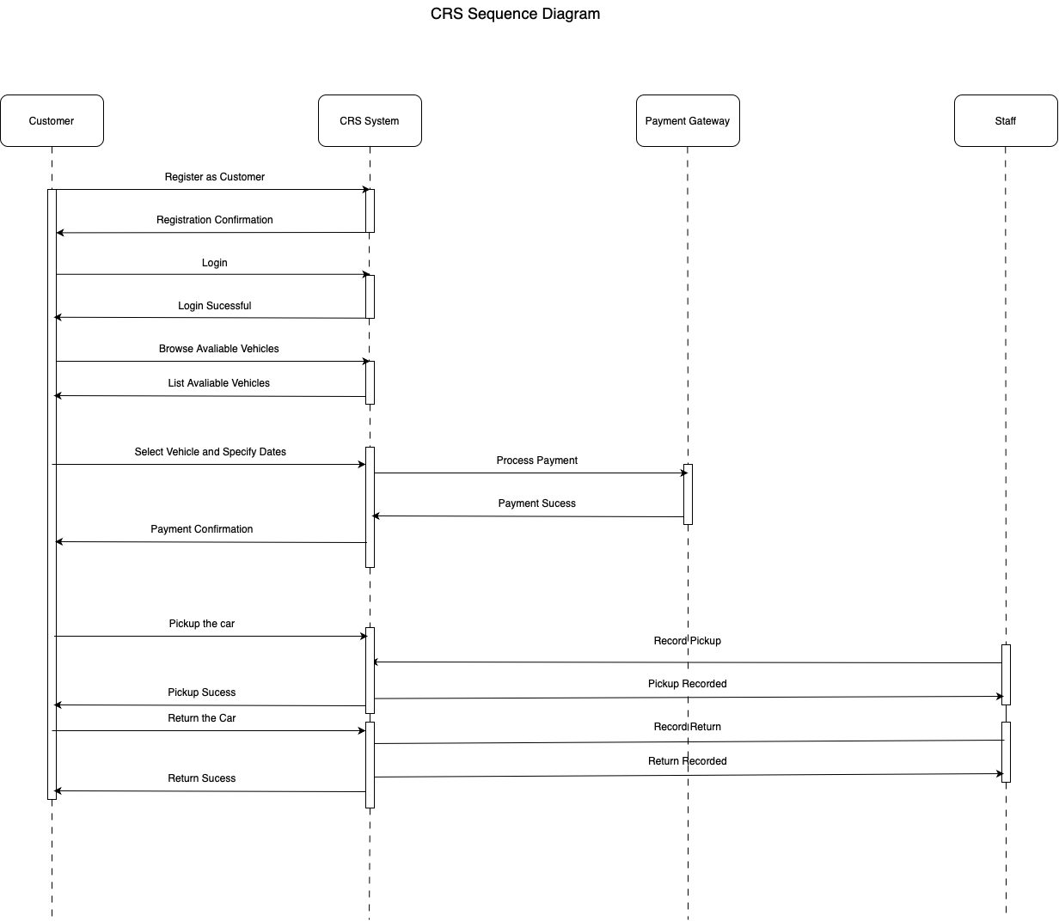

1. **Class Diagram**

